CHAPTER – 6
IMPLEMENTATION

6.1 Concept
Plug your ESP32 development board to your computer and follow these next instructions:
1) Go to Tools > Board, scroll down to the ESP32 section and select the name of your ESP32 board. In my case, it’s the DOIT ESP32 DEVKIT V1 board.
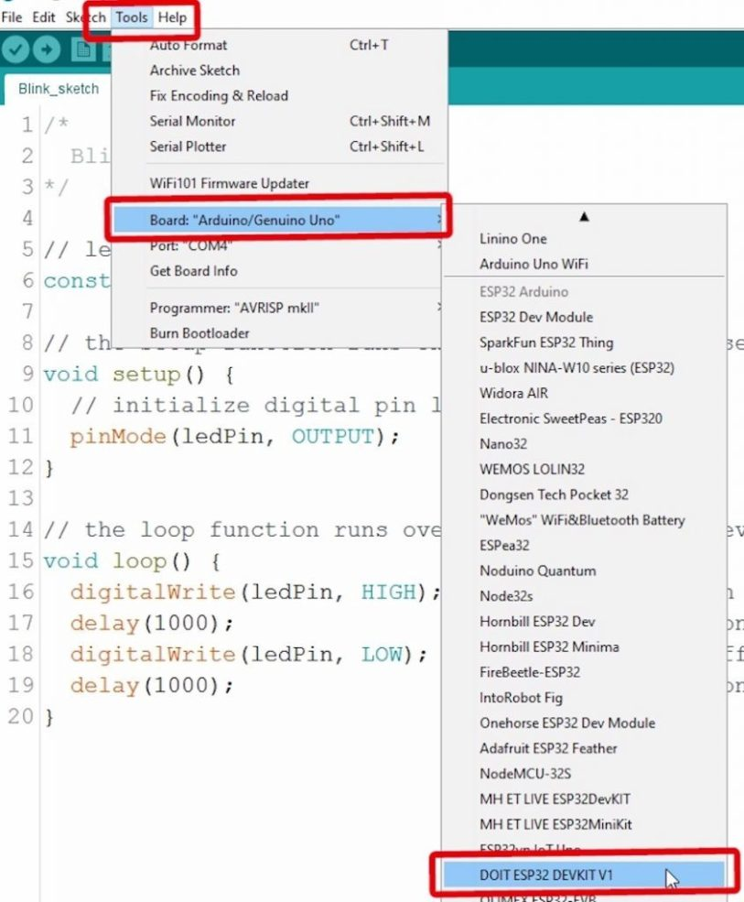

2) Go to Tools > Port and select a COM port available.
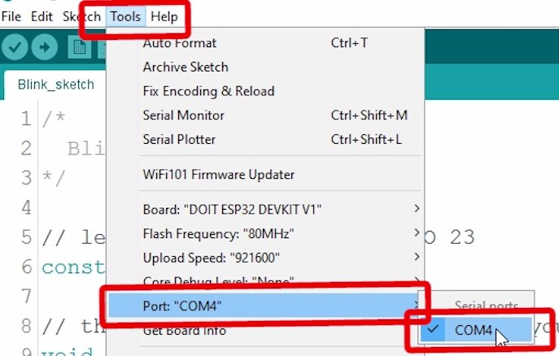
3) Press the upload button.
That’s it!
Note: If you get the following error when trying to upload code, it means that your ESP32 is not in flashing/uploading mode.

Failed to connect to ESP32: Timed out... Connecting...
To upload code, you need to follow the next steps (make sure you have the right board selected:
- Hold-down the “BOOT” button in your ESP32 board

- After you see the “Connecting….” message in your Arduino IDE, release the finger from the “BOOT” button:

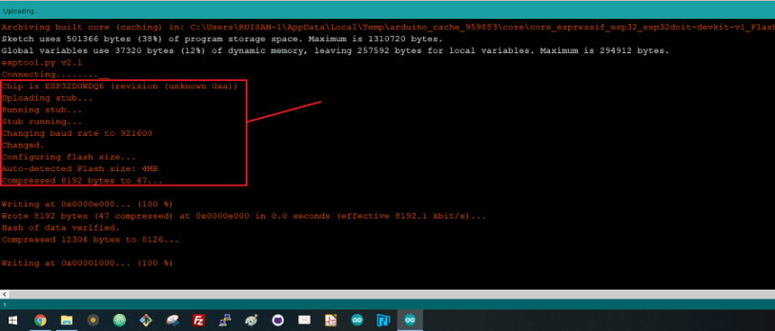
- After that, you should see the “Done uploading” message.
That’s it. After uploading the new sketch, you can press the “ENABLE” button to restart the ESP32 and run the new uploaded sketch.

ARDUINO IDE
Arduino first and foremost is an open-source computer hardware and software company. The Arduino Community refers to the project and user community that designs and utilizes microcontroller-based development boards. These development boards are known as Arduino Modules, which are open-source prototyping platforms. The simplified microcontroller board comes in a variety of development board packages.

The most common programming approach is to use the Arduino IDE, which utilizes the C programming language. This gives you access to an enormous Arduino Library that is constantly growing thanks to open-source community.
Arduino IDE is not: AVR Studio (Yes, we know you loved EE 346, but unfortunately you won’t be utilizing Assembly Language)

Find out all the information you ever wanted to know about Arduino here: https://learn.sparkfun.com/tutorials/what-is-an-arduino Also, checkout sparkfun’s Arduino
Buying Guide for further information on available dev. boards: https://www.sparkfun.com/arduino_guide
Download Arduino Integrated Design Environment (IDE) here (Most recent version: 1.6.5): https://www.arduino.cc/en/Main/Software This is the Arduino IDE once it’s been opened. It opens into a blank sketch where you can start programming immediately. First, we should configure the board and port settings to allow us to upload code. Connect your Arduino board to the PC via the USB cable.
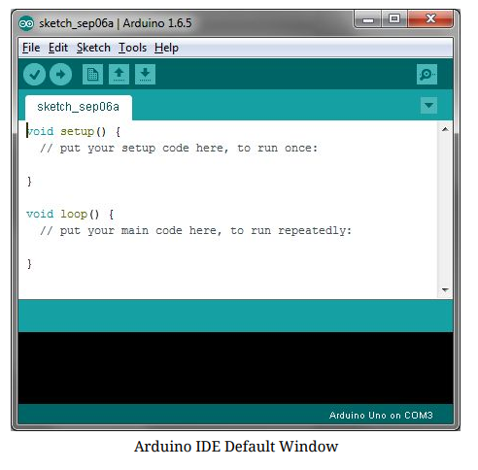
Board Setup
You have to tell the Arduino IDE what board you are uploading to. Select the Toolspulldown menu and go to Board.This list is populated by default with the currently available Arduino Boards that are developed by Arduino. If you are using an Uno or an Uno-Compatible Clone (ex. Funduino, SainSmart, IEIK, etc.), select Arduino Uno. If you are using another board/clone, select that board.
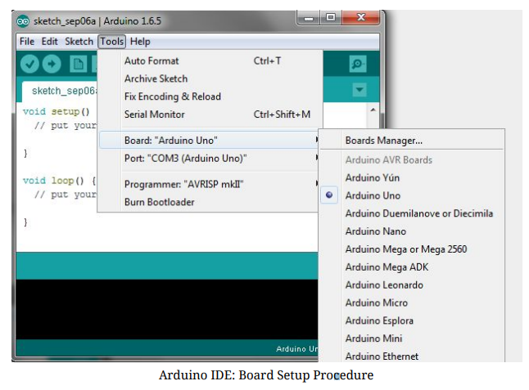

IDE: COM Port Setup
If you downloaded the Arduino IDE before plugging in your Arduino board, when you plugged in the board, the USB drivers should have installed automatically. The most recent Arduino IDE should recognize connected boards and label them with which COM port they are using. Select the Tools pulldown menu and then Port.Here it should list all open COM ports, and if there is a recognized Arduino Board, it will also give it’s name. Select the Arduino board that you have connected to the PC. If the setup was successful, in the bottom right of the Arduino IDE, you should see the board type and COM number of the board you plan to program. Note: the Arduino Uno occupies the next available COM port; it will not always be COM3.
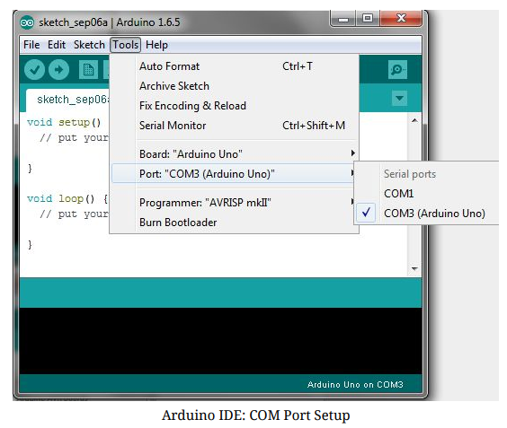
At this point, our board should be set up for programming, and you can begin writing and uploading code.

BLYNK
Blynk was designed for the Internet of Things. It can control hardware remotely, it can display sensor data, it can store data, vizualize it and do many other cool things.
There are three major components in the platform:
- Blynk App - allows to you create amazing interfaces for your projects using various widgets we provide.
- Blynk Server - responsible for all the communications between the smartphone and hardware. You can use our Blynk Cloud or run your private Blynk server locally. It’s open-source, could easily handle thousands of devices and can even be launched on a Raspberry Pi.
- Blynk Libraries - for all the popular hardware platforms - enable communication with the server and process all the incoming and outcoming commands.
Now imagine: every time you press a Button in the Blynk app, the message travels to space the Blynk Cloud, where it magically finds its way to your hardware. It works the same in the opposite direction and everything happens in a blynk of an eye.

Features
- Similar API & UI for all supported hardware & devices
- Connection to the cloud using:
  - WiFi
  - Bluetooth and BLE
  - Ethernet
  - USB (Serial)
  - GSM
- Set of easy-to-use Widgets
- Direct pin manipulation with no code writing
- Easy to integrate and add new functionality using virtual pins
- History data monitoring via SuperChart widget
- Device-to-Device communication using Bridge Widget
- Sending emails, tweets, push notifications, etc.
- new features are constantly added!
You can find example sketches covering basic Blynk Features. They are included in the library. All the sketches are designed to be easily combined with each other.

What do I need to Blynk?
At this point you might be thinking: “Ok, I want it. What do I need to get started?” – Just a couple of things, really:

1. Hardware
An Arduino, Raspberry Pi, or a similar development kit.
Blynk works over the Internet. This means that the hardware you choose should be able to connect to the internet. Some of the boards, like Arduino Uno will need an Ethernet or Wi-Fi Shield to communicate, others are already Internet-enabled: like the ESP8266, Raspberri Pi with WiFi dongle, Particle Photon or SparkFun Blynk Board. But even if you don’t have a
shield, you can connect it over USB to your laptop or desktop (it’s a bit more complicated for newbies, but we got you covered). What’s cool, is that the list of hardware that works with Blynk is huge and will keep on growing.

2. A Smartphone.
The Blynk App is a well-designed interface builder. It works on both iOS and Android.
Getting Started
Let’s get you started in 5 minutes (reading doesn’t count!). We will switch on an LED connected to your Arduino using the Blynk App on your smartphone.
Connect an LED as shown here:
Getting Started With The Blynk App

1. Create a Blynk Account
After you download the Blynk App, you’ll need to create a New Blynk account. This account is separate from the accounts used for the Blynk Forums, in case you already have one.
We recommend using a real email address because it will simplify things later.
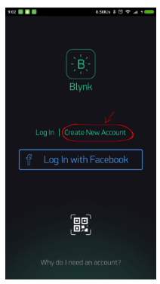

Why do I need to create an account?
An account is needed to save your projects and have access to them from multiple devices from anywhere. It’s also a security measure.
You can always set up your own Private Blynk Server and have full control
Create a New Project
After you’ve successfully logged into your account, start by creating a new project.
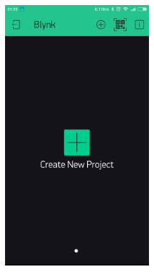

Choose Your Hardware
Select the hardware model you will use. Check out the list of supported hardware!
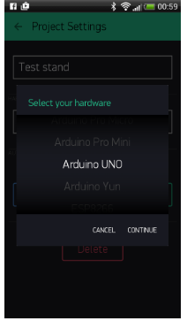

Auth Token
Auth Token is a unique identifier which is needed to connect your hardware to your smartphone. Every new project you create will have its own Auth Token. You’ll get Auth
Token automatically on your email after project creation. You can also copy it manually. Click on devices section and selected required device :
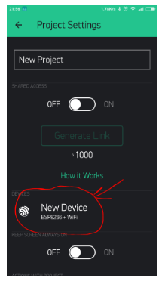
It’s very convenient to send it over e-mail. Press the e-mail button and the token will be sent to the e-mail address you used for registration. You can also tap on the Token line and it will be copied to the clipboard.
Now press the “Create” button.

Add a Widget
Your project canvas is empty, let’s add a button to control our LED.
Tap anywhere on the canvas to open the widget box. All the available widgets are located here. Now pick a button.
Widget Box
Drag-n-Drop - Tap and hold the Widget to drag it to the new position.
Widget Settings - Each Widget has it’s own settings. Tap on the widget to get to them.

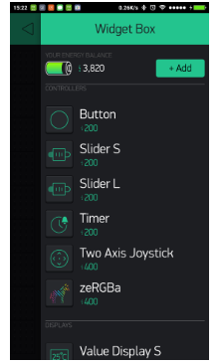
Run The Project
When you are done with the Settings - press the PLAY button. This will switch you from EDIT mode to PLAY mode where you can interact with the hardware. While in PLAY mode, you won’t be able to drag or set up new widgets, press STOP and get back to EDIT mode.
You will get a message saying “Arduino UNO is offline”. We’ll deal with that in the next section.

Getting Started With Hardware
How To Use an Example Sketch
You should by now have the Blynk Library installed on your computer. If not - click here.
Example sketches will help you get your hardware online quickly and major Blynk features.
Open the example sketch according to the hardware model or shield you are using.

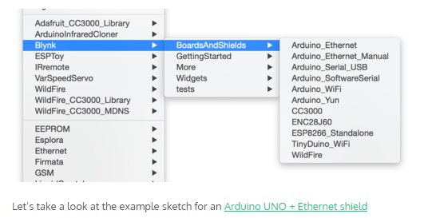
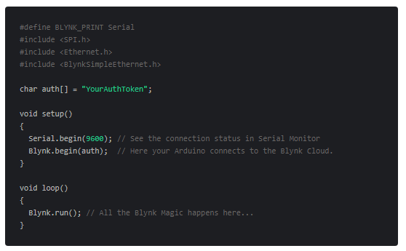

Auth Token
In this example sketch, find this line:
char auth[] = "YourAuthToken";
This is the Auth Token that you emailed yourself. Please check your email and copy it, then paste it inside the quotation marks.
It should look similar to this:
char auth[] = "f45626c103a94983b469637978b0c78a";
Upload the sketch to the board and open Serial Terminal. Wait until you see something like this:
Blynk v.X.X.X
Your IP is 192.168.0.11
Connecting...
Blynk connected!
Congrats! You are all set! Now your hardware is connected to the Blynk Cloud!

Blynking
Go back to the Blynk App, push the button and turn the LED on and off! It should be Blynking
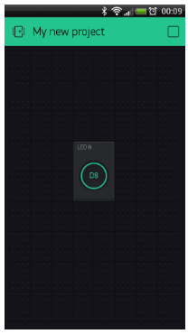
Check out other example sketches.
Feel free to experiment and combine different examples together to create your own amazing projects.
For example, to attach an LED to a PWM-enabled Pin on your Arduino, set the slider widget to control the brightness of an LED. Just use the same steps described above.

The relay module is an electrically operated switch that allows you to turn on or off a circuit using voltage and/or current much higher than a microcontroller could handle. There is no connection between the low voltage circuit operated by the microcontroller and the high power circuit. The relay protects each circuit from each other.
The each channel in the module has three connections named NC, COM, and NO. Depending on the input signal trigger mode, the jumper cap can be placed at high level effective mode

which ‘closes’ the normally open (NO) switch at high level input and at low level effective mode which operates the same but at low level input.
Specifications
- On-board EL817 photoelectric coupler with photoelectric isolating anti-interference ability strong
- On-board 5V, 10A / 250VAC, 10A / 30VDC relays
- Relay long life can absorb 100000 times in a row
- Module can be directly and MCU I/O link, with the output signal indicator
- Module with diode current protection, short response time
- PCB Size: 45.8mm x 32.4mm

Pin Configuration
1. VCC: 5V DC
2. COM: 5V DC
3. IN1: high/low output
4. IN2: high/low output
5. GND: ground
6.2 Algorithm
#include <dummy.h>

/*************************************************************
Download latest Blynk library here:
https://github.com/blynkkk/blynk-library/releases/latest

Blynk is a platform with iOS and Android apps to control
Arduino, Raspberry Pi and the likes over the Internet.
You can easily build graphic interfaces for all your
projects by simply dragging and dropping widgets.

Downloads, docs, tutorials: http://www.blynk.cc
Sketch generator: http://examples.blynk.cc
Blynk community: http://community.blynk.cc
Follow us: http://www.fb.com/blynkapp
http://twitter.com/blynk_app

Blynk library is licensed under MIT license
This example code is in public domain.

*************************************************************
This example runs directly on NodeMCU.

Note: This requires ESP8266 support package:
https://github.com/esp8266/Arduino

Please be sure to select the right NodeMCU module
in the Tools -> Board menu!

For advanced settings please follow ESP examples :
- ESP8266_Standalone_Manual_IP.ino
- ESP8266_Standalone_SmartConfig.ino
- ESP8266_Standalone_SSL.ino

Change WiFi ssid, pass, and Blynk auth token to run :)
Feel free to apply it to any other example. It's simple!
*************************************************************/

/* Comment this out to disable prints and save space */
#define BLYNK_PRINT Serial

#include <ESP8266WiFi.h>
#include <BlynkSimpleEsp8266.h>

// You should get Auth Token in the Blynk App.
// Go to the Project Settings (nut icon).
char auth[] = "yLr8OrasmGm0y8e6QYlfkuEYbrqBkenP";

// Your WiFi credentials.
// Set password to "" for open networks.
char ssid[] = "Anirudh";
char pass[] = "Abcd@120";
void setup()
{
// Debug console
Serial.begin(9600);

Blynk.begin(auth, ssid, pass);
// You can also specify server:
//Blynk.begin(auth, ssid, pass, "blynk-cloud.com", 80);
//Blynk.begin(auth, ssid, pass, IPAddress(192,168,1,100), 8080);
}

void loop()
{
Blynk.run();

